**Human Computer Interaction**

**Final Project Report**

Project name : “FriendBot”

Student names : Peter Nelson Subrata, Philipus Adriel Tandra

Student IDs: 2502023562, 2502031715

Class: L1CC

# 

Table of Contents

Problem…………………………………………………………………………….. 3

UML Use Case…………………………………………………………………….. 4

UML Use Case Diagram…………………………………………………………... 5

Activity Diagram…………………………………………………………………... 6

User Personas……………………………………………………………………… 6

Test Cases………………………………………………………………………….. 7

Collaboration Log………………………………………………………………… 11

Reflection - Philipus Adriel Tandra………………………………………………. 11

Reflection - Peter Nelson Subrata………………………………………………... 12

References………………………………………………………………………... 13

# **Problem**

We aimed to create a website that could solve loneliness. What better way to do it than with a chatbot? It would always be there, respond with full energy and be easier to talk to. It could do things that a human would be unable to replicate and as a result, FriendBot was born. We aimed for it to also encourage and give advice to those who are undergoing unfortunate circumstances such as depression, anxiety and suicidal tendencies. This is because this target tends to suffer from isolation or it can act as a catalyst for these mental health problems (Novotney, 2019).

We also thought of and were partly inspired by other websites that had similar goals such as Omegle and aimed to replicate their vision. We thought to put in a video chat system that would help connect strangers from all over the world to help people get to know each other, however, we thought to create guidelines by incorporating a trust factor system to help combat against the potential for inconsiderate people.

Design

We decided on a more inviting and expressive design as it would help the user be not only more attracted to the website but also be more curious and learn about what the website is all about. This plays a key role in user learnability where the user can navigate and see the different features of the website. We also wanted to incorporate colors and decided on aquamarine. This is because colors play a key role in design not only for the purposes of looking nicer but also plays a part in human psychology. Colors can be associated with a person's emotions and thus directly play a part in it. We decided on aquamarine as it has a nice calming presence due to the mixture of blue and green.

We also tried to make it eye-catching with brighter and contrasting colors such as the text boxes in the main page. Another thing we tried to do is make it have a self-explanatory interface by being very clear on what the purpose of a page on the website is for based on the way it looks and the way it is explained through text. This plays a vital role in the user experience as the website is not too complex and is much easier for the user to access the website. Overall, the website looks crowded and bombastic, the perfect concoction for a lonely user.

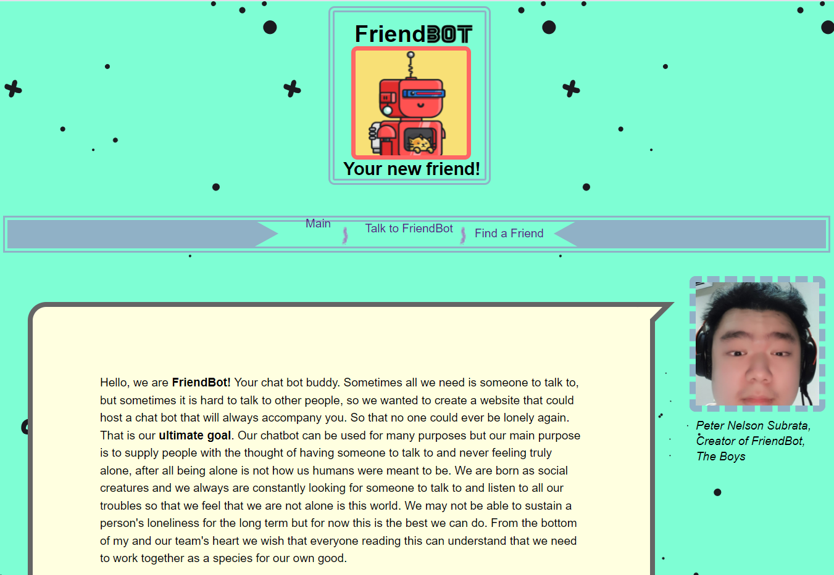

**Figure I:** Main Page

# **UML Use Case**

1. Chatbot waits for input for the user.
2. The user inputs a text.
3. The Chatbot checks the input for a response.
4. The Chatbot finds a response for the input.
5. The Chatbot responds with a reply.

# **UML Use Case Diagram**

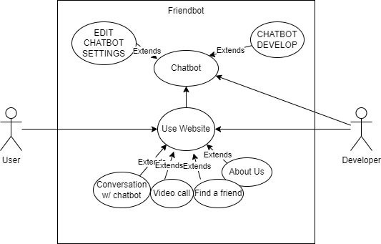

**Figure II:** UML Use Case Diagram

# **Activity Diagram**

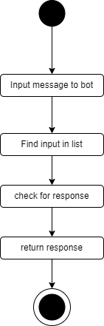

**Figure III:** UML Activity diagram based on the use case

# **User Personas**

Chad is a university student who is very congenial, but most of his time with his friends is reduced due to the pandemic and upcoming final projects and exams. He stumbles across FriendBot one day as he is very bored and done with studying. He is glad that FriendBot is there during the pandemic as there is someone for him to always talk to and meet new strangers and potential friends. He can also analyze FriendBot for one of his project case studies. Chad has completed his goal of making more friends and feeling entertained during these tough times.

Pamela is a manager at a big company and is mostly busy. She is friendly with her coworkers but their relationship to one another is no more than just acquainted colleagues. She stumbles upon FriendBot and is delighted to spend her breaks after her shifts typing away talking to FriendBot. Pamela also finds the “Find a Friend” feature intriguing and uses it to network and get to know more people while finding suitable candidates for her business and learn more about what customers nowadays are interested in. Pamela completes her goal of making friends and creating connections with people all over the world.

Jack is a highschool student who is undergoing mental trauma from the death of his best friend. As a result, he tends to stay away from people due to his past trauma and is undergoing depression. He stumbles upon FriendBot and is hooked. As FriendBot will not ever leave Jack, he is grateful and goes on the website everyday venting his problems and frustrations while FriendBot provides him with encouraging words and advice. Jack has completed his goal of finding someone to talk and vent his frustrations out to. He also is able to recover from his trauma easier now that his mental health is better.

These three user personas highlight the different ways people can use FriendBot like meeting and making new friends, networking, increasing business opportunities and for help with mental problems that could arise from trauma or other unfortunate circumstances.

# **Test Cases**

| **TEST CASE ID** | **Description** | **Test Steps** | **Test Data** | **Expected Result** | **Status** |
| --- | --- | --- | --- | --- | --- |
| TEST CASE NO 1 | The user inputs no input | 1. Click say something box 2. Press enter 3. Wait | Input: “”(no input)  Output: Please say something :( | Prompts user to say something | PASS |
| TEST CASE NO 2 | The user asks “who created you” | 1. Click say something box 2. Type “who created you” 3. Wait | Input: “who created you”  Output: “My creator is Peter Nelson Subrata, he is very cool and sexy and also Philipus Adriel Tandra :)” | Informs the user the creator’s names | PASS |
| TEST CASE NO 3 | The user repeatedly inputs “im sad” over three times | 1. Click say something box 2. Type im sad 3. Wait 4. Type im sad 5. Wait 6. Type im sad 7. Wait | Input:  “im sad”  “im sad”  “im sad”  Output:  “Hey man we all have our ups and downs, sometimes its just about going strong and being able to conquer your weaknesses”  “dont be so down, it'll get better I promise”  “When life gives you lemons, make lemonade” | Gives the user motivational words | PASS |
| TEST CASE NO 4 | The user inputs “what is your name” | 1. Click say something box 2. Type what is your name 3. Wait | Input: “what is your name”  Output: “My name is FriendBot, Nice to meet you” | Introduces itself | PASS |

In conclusion, our white-box penetration alpha tests aimed to try and test the bot to meet our expectations and it shows us its capabilities were satisfactory. There are still many things that the FriendBot is capable of doing that are exempt from the test cases above. It has also continued the goal of providing support and motivation to those in need and being very responsive to all kinds of inputs.

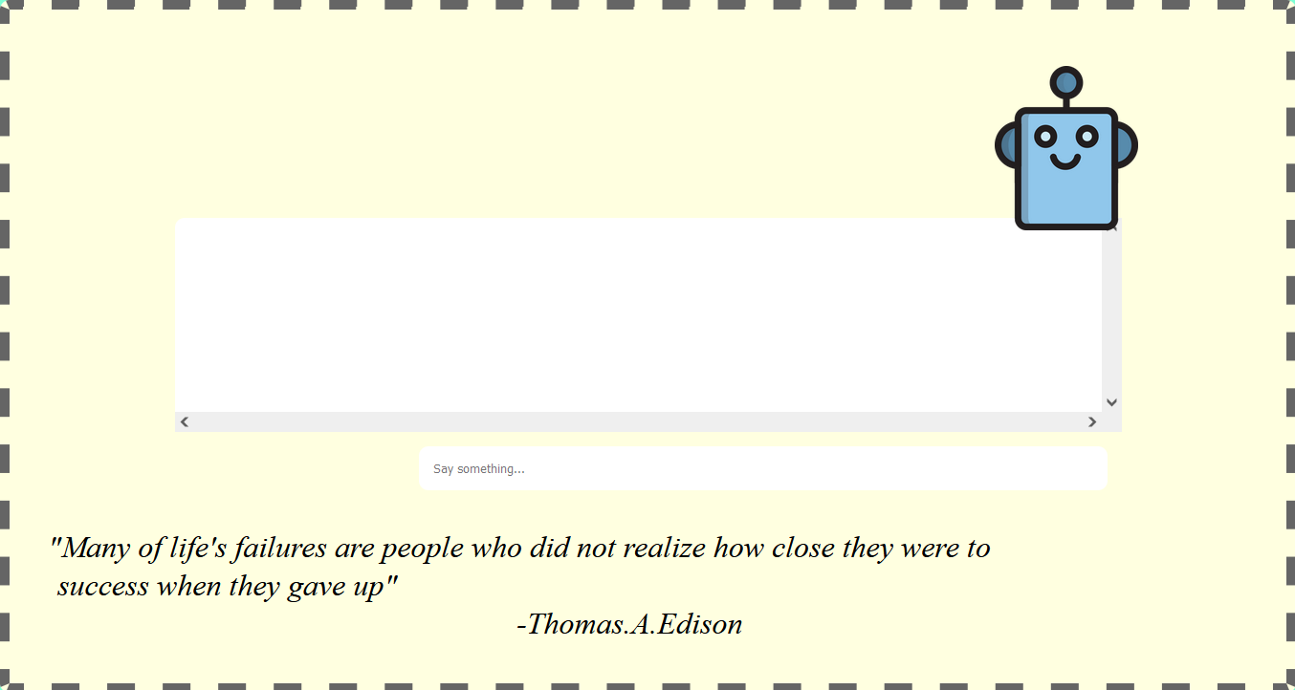

**Figure IV:** Chatbot

# **Collaboration Log**

Javascript - Peter Nelson Subrata

CSS - Peter Nelson Subrata

HTML - Peter Nelson Subrata, Philipus Adriel Tandra

Design - Peter Nelson Subrata, Philipus Adriel Tandra

Assets - Peter Nelson Subrata, Philipus Adriel Tandra

Test Cases - Philipus Adriel Tandra

UML - Peter Nelson Subrata

Poster - Philipus Adriel Tandra

Storyboard - Peter Nelson Subrata

User Personas - Philipus Adriel Tandra

Report - Philipus Adriel Tandra

Video - Peter Nelson Subrata, Philipus Adriel Tandra

# **Reflection - Philipus Adriel Tandra**

This project has had a lot of ups and downs, just like life. First and foremost, I want to go over my experiences with this project. I learnt a lot of things related and unrelated to computer science. All of which were very important in my life. Website design was also very interesting, unlike in our class Algorithm and Programming, the visual is one of the main key things in web design as opposed to the raw functionality of a python program. It was very interesting and the culmination of JavaScript, CSS and HTML all coming together to create one website was something very beautiful. At the end of the day, collaboration and togetherness is what wins our battles, just like the main premise of our website. My collaboration with my partner, Peter Nelson Subrata is one that I will never forget, the coming together of computer scientists is very prominent in our future careers such as creating games or in a workplace environment. I want to thank my partner for teaching me the different things about code, since I do not regard myself as nearly as great of a coder as he is and especially Sir Bagus, for helping me and letting me use all of the things he has taught me and putting them to practical use.

**Thank you, Sir Bagus**

# **Reflection - Peter Nelson Subrata**

There was a time in my life where I was super lonely myself, especially during quarantine and when I experienced what that kind of loneliness felt like it really makes me sad that a lot of people out there are also experiencing severe loneliness. When I first made the website the goal was clear, I wanted to help people who had the same problems I have faced. I coded in a chatbot that responds based on the user input and made a supporting website with my pal Philip. I learned along the way how to make a design that emotionally connects with the user. Through this ability I was able to make a website that I thought could truly help people face their problems. I know the website and features are still mostly incomplete, but I am to progress further as I sharpen my skills as a programmer and hopefully help others along the way. This concludes my reflection.

*Thank you, Sir Bagus*

# 

**Figure V:** The Boys

# **References**

Novotney, A. (2019, May). The risks of social isolation. *Monitor in Psychology*, *50* (5). Retrieved from, <https://www.apa.org/monitor/2019/05/ce-corner-isolation>

Unknown Author, (Unknown Date). *Color Psychology: The Psychology of colors.* Retrieved from, [http://www.arttherapyblog.com/online/color-psychology-psychologica-effects-of-color](http://www.arttherapyblog.com/online/color-psychology-psychologica-effects-of-colors/)/

Peter Nelson Subrata, Philipus Adriel Tandra (2022). FriendBot. Retrieved from, https://github.com/CH1MP5T0N/TheBoys_Friendbot